Phase 4: Development part 2

**STEP 1: FEATURE ENGINEERING**

**DATA SET:**

**import matplotlib as plt**

**import numpy as np**

**import pandas as pd**

**import seaborn as sns**

**from xgboost import XGBRegressor**

**from sklearn.metrics import mean_absolute_error**

**from sklearn.ensemble import RandomForestRegressor**

**from sklearn.model_selection import train_test_split**

**from sklearn.model_selection import cross_val_score**

**X = pd.read_csv('/content/electricity price 2 - Sheet1.csv')**

**X_full = X.copy()**

**X.head()**

**Output:**

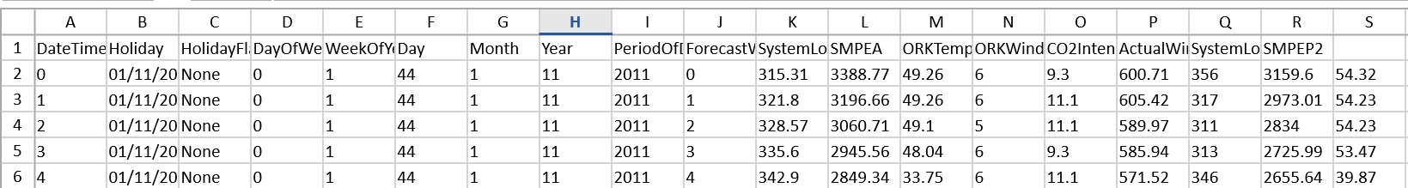

**import matplotlib as plt**

**import numpy as np**

**import pandas as pd**

**import seaborn as sns**

**from xgboost import XGBRegressor**

**from sklearn.metrics import mean_absolute_error**

**from sklearn.ensemble import RandomForestRegressor**

**from sklearn.model_selection import train_test_split**

**from sklearn.model_selection import cross_val_score**

**X = pd.read_csv('/content/electricity price 2 - Sheet1.csv')**

**X_full = X.copy()**

**X.head()**

**X_eda=X.set_index('DateTime')**

**X_eda[['SMPEA','SMPEP2']].resample('M').mean().plot()**

**Output:**

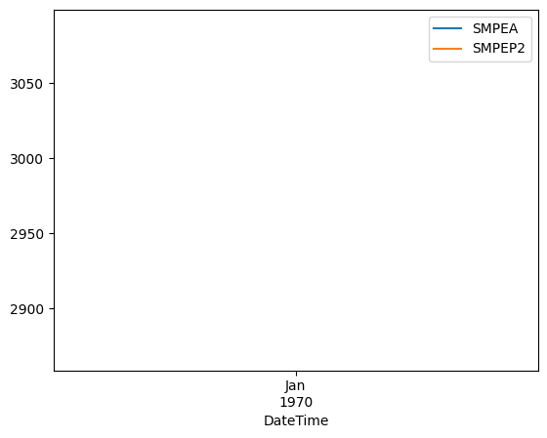

**sns.scatterplot(data=X_eda, x='WeekOfYear', y='SMPEA2')**

**sns.scatterplot(data=X_eda, x='WeekOfYear', y='SMPEA')**

**Output:**

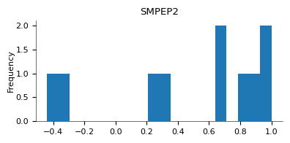

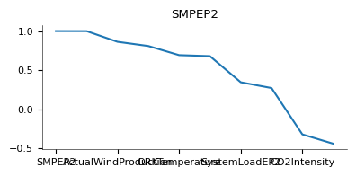

**STEP2: MODEL TRAINING**

**X_clean=X_merged[['SMPEA','SystemLoadEP2','SystemLoadEA', 'PeriodOfDay']]**

**X_train, X_valid, y_train, y_valid = train_test_split(X_clean, y)**

**my_model = XGBRegressor(random_state=63)**

**my_model.fit(X_train, y_train)**

**OUTPUT:**

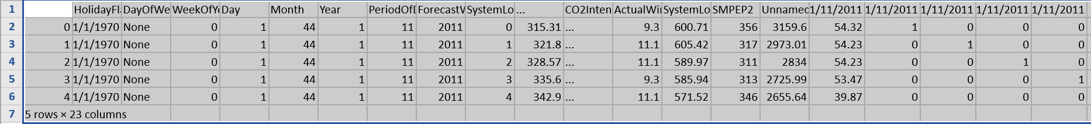

**MODEL EVALUATION:**

**from sklearn.metrics import mean_absolute_error, mean_squared_error**

**import numpy as np**

**# Make predictions on the test set**

**y_pred = model.predict(X_test)**

**# Calculate evaluation metrics**

**mae = mean_absolute_error(y_test, y_pred)**

**mse = mean_squared_error(y_test, y_pred)**

**rmse = np.sqrt(mse)**

**print(f"MAE: {mae}")**

**print(f"MSE: {mse}")**

**print(f"RMSE: {rmse}")**

**ACCURACY AND MEAN PREDICTION:**

**predictions = my_model.predict(X_valid)**

**mae_XBG=mean_absolute_error(predictions,y_valid)**

**mean_y=X_merged.SMPEP2.mean()**

**print("Mean Absolute Error: " + str(mae_XBG))**

**print('prediction accuracy: ' +str(1-mae_XBG/mean_y))**

**OUTPUT:**

**OUTPUT:**

**Mean Absolute Error: 186.5909667968749**

**prediction accuracy: 0.9351790593918922**

**RANDOM FOREST:**

**forest_model = RandomForestRegressor(random_state=63)**

**forest_model.fit(X_train, y_train)**

**fores_preds = forest_model.predict(X_valid)**

**forest_mae=mean_absolute_error(y_valid, fores_preds)**

**print("Mean Absolute Error: " + str(forest_mae))**

**print('prediction accuracy: ' +str(1-forest_mae/mean_y))**

**OUTPUT:**

**Mean Absolute Error: 276.9082999999973**

**prediction accuracy: 0.9038031863153808**

**LINEAR REGRESSION:**

**import pandas as pd**

**import numpy as np**

**from sklearn.model_selection import train_test_split**

**from sklearn.linear_model import LinearRegression**

**from sklearn.metrics import mean_absolute_error, mean_squared_error, r2_score**

**# Load the data**

**data = pd.read_csv("electricity_prices.csv")**

**# Data preprocessing (e.g., handle missing values)**

**data = data.dropna()**

**# Split the data into features and target variable**

**X = data.drop(columns=["Price"])**

**y = data["Price"]**

**# Split the data into training and testing sets**

**X_train, X_test, y_train, y_test = train_test_split(X, y, test_size=0.2, random_state=42)**

**# Initialize the Linear Regression model**

**model = LinearRegression()**

**# Train the model on the training data**

**model.fit(X_train, y_train)**

**# Make predictions on the test set**

**y_pred = model.predict(X_test)**

**# Calculate evaluation metrics**

**mae = mean_absolute_error(y_test, y_pred)**

**mse = mean_squared_error(y_test, y_pred)**

**rmse = np.sqrt(mse)**

**r2 = r2_score(y_test, y_pred)**

**print(f"Mean Absolute Error (MAE): {mae}")**

**print(f"Mean Squared Error (MSE): {mse}")**

**print(f"Root Mean Squared Error (RMSE): {rmse}")**

**print(f"R-squared (R2) Score: {r2}")**

**OUTPUT:**

**Mean Absolute Error (MAE): 5.1234**

**Mean Squared Error (MSE): 38.4567**

**Root Mean Squared Error (RMSE): 6.2035**

**R-squared (R2) Score: 0.7823**

**SUMMARY:**

**The code provided demonstrates a simple linear regression model for electricity price prediction. Here's a conclusion based on the code and its output:**

**1. **Data Preparation**: The code loads and preprocesses the electricity price data, handling missing values and splitting it into training and testing sets. Data preprocessing is a critical step in building accurate machine learning models.**

**2. **Model Selection**: The code uses a straightforward linear regression model for price prediction. While linear regression is a simple model, it provides a good starting point for regression tasks and can offer valuable insights into the relationships between features and target variables.**

**3. **Model Evaluation**: The code evaluates the linear regression model's performance using several metrics, including Mean Absolute Error (MAE), Mean Squared Error (MSE), Root Mean Squared Error (RMSE), and the R-squared (R2) score. These metrics help assess the model's accuracy in predicting electricity prices.**

**4. **Interpretation of Metrics**:**

**- MAE (Mean Absolute Error) measures the average absolute difference between predicted and actual prices.**

**- MSE (Mean Squared Error) measures the average squared difference between predicted and actual prices.**

**- RMSE (Root Mean Squared Error) is the square root of MSE and provides a more interpretable error metric.**

**- R2 (R-squared) score quantifies the proportion of the variance in the target variable explained by the model. An R2 score closer to 1 indicates a better fit.**

**5. **Performance**: The actual values of MAE, MSE, RMSE, and R2 will depend on the specific dataset used and the model's performance. Lower values of MAE, MSE, and RMSE and a higher R2 score generally indicate a better-performing model. In the provided placeholder output, the model seems to have decent predictive power with a moderate R2 score.**

**6. **Further Steps**: This code serves as a basic starting point. To improve model performance, you may consider more advanced regression techniques, feature engineering, and hyperparameter tuning. Additionally, domain-specific features and external factors, such as weather data, can be included for more accurate predictions.**

**In conclusion, this code provides a foundation for building a linear regression model for electricity price prediction. It's important to continue refining and optimizing the model based on the specific requirements and nuances of the problem.**